CHC62015M Advanced Diploma of Community Sector Management
Release 2

CHC62015M Advanced Diploma of Community Sector Management

Modification History

Release | Comments
Release 1 | This version released with CHC Community Services Training Package Version 11.  CHC62015M Advanced Diploma of Community Sector Management supersedes and is not equivalent to CHC62015 Advanced Diploma of Community Sector Management.  Major changes to core and elective units of competency.

Qualification code  DRAFT  Mandatory field | CHC62015M
Qualification title  Mandatory field | Advanced Diploma of Community Sector Management
Qualification description  Mandatory field | This qualification reflects the role of workers who are middle managers or managers across a range of community sector organisations. These people work independently and report to executive management, directors or boards of management. They undertake a range of functions requiring the application of knowledge and skills to achieve results in line with the organisation's goals and strategic directions.  At this level, workers have responsibility for planning and monitoring service delivery, recruitment and performance management of other paid or unpaid workers, managing risk and contributing to continuous improvement within the scope of their specific role. This may include management of a specific program or project, or broader management of community services organisations such as a community-based organisation, early childhood education service, not-for-profit organisation or community centre.  The skills in this qualification must be applied in accordance with Commonwealth and State or Territory legislation, Australian standards and industry codes of practice.
Foundation skills outcomes  Mandatory field | The foundation skills outcomes implicit in this qualification are outlined in the below bar chart.  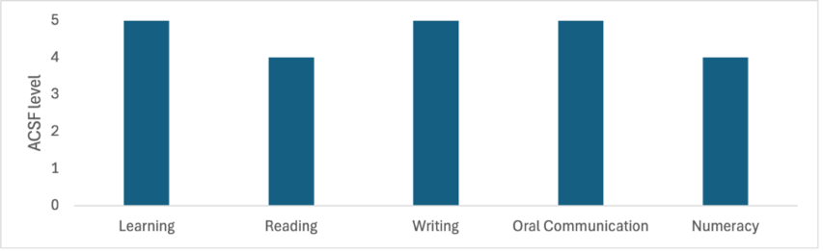  Note: Some elective units require higher foundation skills levels. Please refer to the Companion Volume Implementation Guide for more information.
Entry requirements  DRAFT  Optional field | Entry to this qualification is open to individuals who can demonstrate foundational community services competence through:  - a qualification at Certificate IV level or higher in community services; or  - evidence of at least 12 months of work (paid or volunteer) in community services role(s)
Qualification mapping information  Mandatory field | CHC62015M Advanced Diploma of Community Sector Management supersedes and is not equivalent to CHC62015 Advanced Diploma of Community Sector Management.
Packaging Rules | Total number of units = 13  - 9 core units  - 4 elective units, consisting of:  - at least 2 units from the electives listed below  - up to 2 units from any endorsed Training Package or accredited course – these units must be relevant to the work outcome  All electives chosen must contribute to a valid, industry-supported vocational outcome.  *proposed draft title – subject to consultation  M indicates proposed major changes  X indicates cross sector  Core units  BSBFIN601 Manage organisational finances  BSBLDR601 Lead and manage organisational change  BSBOPS504 Manage business risk  BSBPEF401 Manage personal health and wellbeing  BSBSTR601 Manage innovation and continuous improvement  CHCDIV003M Manage and promote diversity  CHCLEG003M Manage legal and ethical compliance  CHCMGT001M *Develop, implement and review quality systems  CHCMGT003 Lead the work team  Elective units  BSBHRM521 Facilitate performance development processes  BSBHRM531 Coordinate health and wellness programs  BSBHRM614 Contribute to strategic workforce planning  BSBINS601 Manage knowledge and information  BSBLDR602 Provide leadership across the organisation  BSBMKG542 Establish and monitor the marketing mix  BSBMKG623 Develop marketing plans  BSBOPS601 Develop and implement business plans  BSBPMG530 Manage project scope  BSBPMG540 Manage project integration  BSBSTR503 Develop organisational policy  BSBSTR602 Develop organisational strategies  BSBSTR603 Develop business continuity plans  BSBSUS511 Develop workplace policies and procedures for sustainability  BSBWHS512 Contribute to managing work-related psychological health and safety  BSBWHS603 Implement WHS risk management  CHCADV004 Represent organisation in court or tribunal  CHCADV005 Provide systems advocacy services  CHCCCS007 Develop and implement service programs  CHCCDE028M Work within organisation and government structures to enable community development outcomes  CHCCDE029 Establish and develop community organisations or social enterprise  CHCCOM003M Develop workplace communication strategies  CHCCSM012 Coordinate complex case requirements  CHCCSM014M Provide case management supervision  CHCDIV002M *Support culturally responsive practices with Aboriginal and/or Torres Strait Islander peoples  CHCECE051 Promote equity in access to the service  CHCECE052 Plan service and supports for children and families  CHCECE053 Respond to grievances and complaints about the service  CHCFAM003 Support people to improve relationships  CHCFAM009 Facilitate family intervention strategies  CHCMGT002 Manage partnership agreements with service providers  CHCMGT004 Secure and manage funding  CHCMGT005 Facilitate workplace debriefing and support processes  CHCMGT006 Coordinate client directed services  CHCMGT007 Work effectively with the Board of an organisation  CHCMHS010 Implement recovery-oriented approaches to complexity  CHCPOL003 Research and apply evidence to practice  CHCPRP003 Reflect on and improve own professional practice  CHCPRP004 Promote and represent the service  CHCPWK006 Promote and conduct mental health peer work  CHCVOL003 Recruit, induct and support volunteers  CHCVOL004 Manage volunteer workforce development  FNSACC634 Monitor corporate governance activities  PSPGEN125 Support workplace coaching and mentoring  PSPLAN003 Source information on Deaf culture, and communicate according to Deaf protocol  PUAEMR035 Facilitate community involvement in recovery  TAEDEL414 Mentor in the workplace

